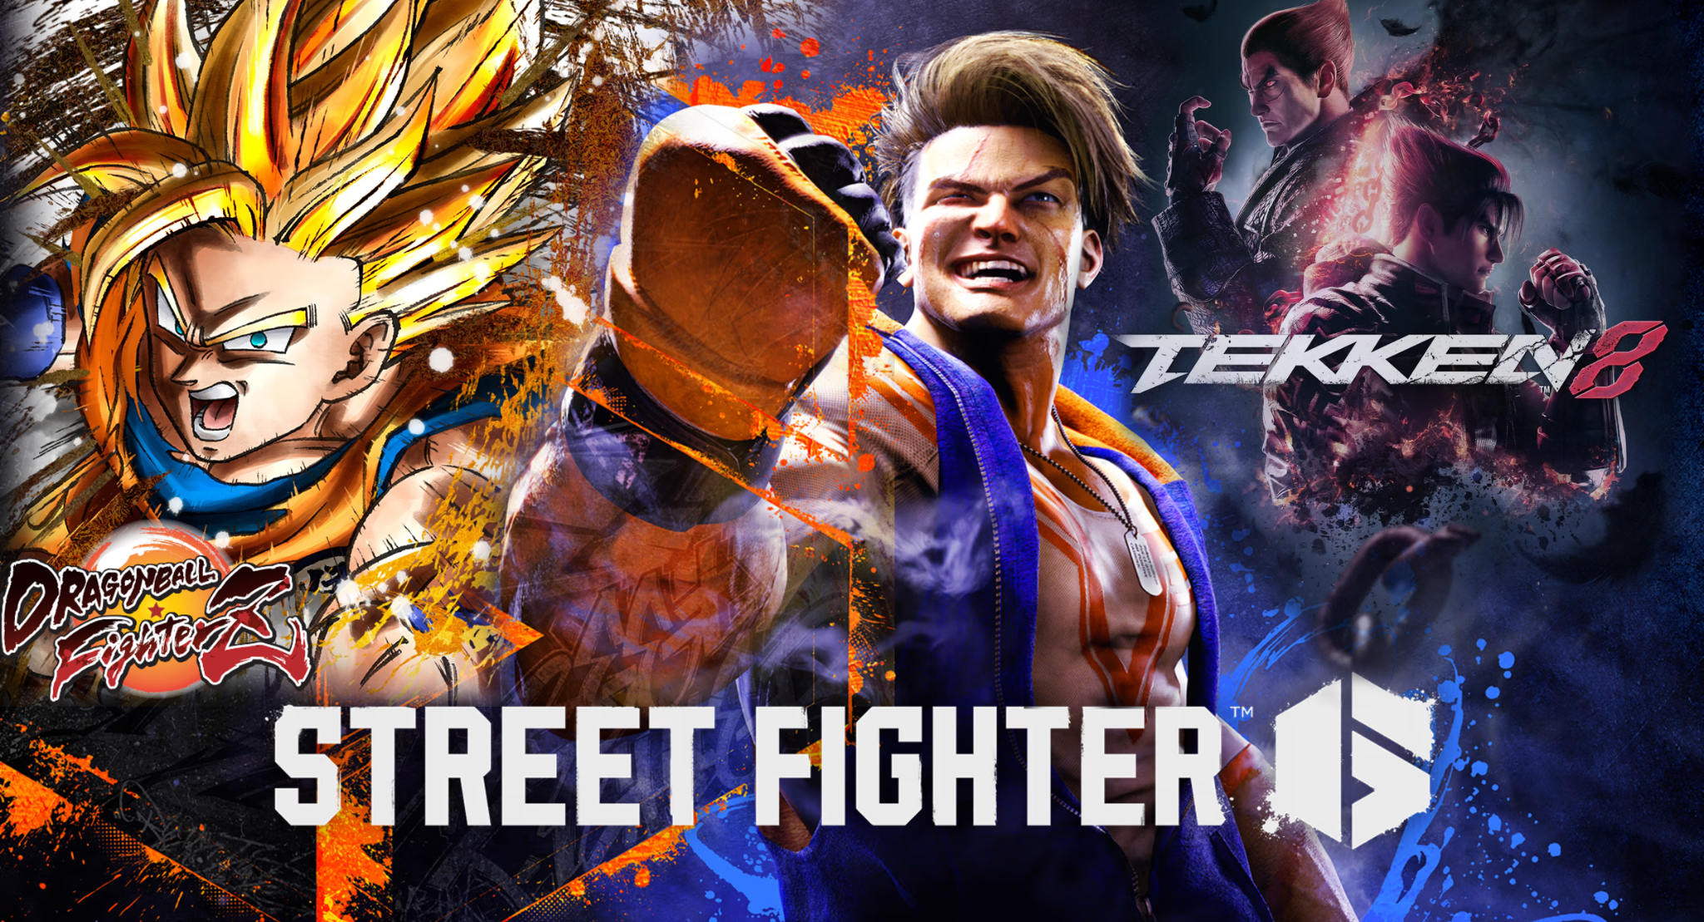

Overview
MSEA is pleased to host three fighting game tournaments at Winnipeg ComicCon: Street Fighter 6, Dragonball Fighterz and Tekken 8! Each tournament will be a separate double elimination bracket.

Date: Saturday, Oct. 31

Tournament Start Times: Check-in for each tournament closes 15 minutes before the listed start time.
Dragonball Fighterz - 10am
Street Fighter 6 - 12pm
Tekken 8 - 2pm

Location: Winnipeg Convention Center

Participants: Each school can register up to 8 players. Spectators are welcome. Coaches are required to attend to supervise their players.

These will be in-person tournaments. Players are encouraged to stay and watch the final. ComicCon passes are not required to participate in the fighting game tournaments.

In the event that a tournament has less than 10 participants, a round robin tournament may be held instead (depending on time) to give participants more opportunities to play.

Xbox controllers and arcade fighting sticks will be provided but we encourage players to bring their own controller along with a cable to connect it to the laptop.

Questions
If you have questions or need more information, please contact the convener via the MSEA discord or email kiefer.macleod@lrsd.net. Please review the rules and registration information below.

Registration Instructions

Online Registration
Register through MS Forms here (this link will also be on discord):
MSEA 2026 ComicCon Fighting Games: SF6, T8, DBFZ (Event#1) – Fill out form
Registration Deadline Monday, October 26. All participants must be registered by this date
The main contact email must be the teacher/coach in charge.

Discord
You should join the MSEA discord server if you have not already. You can chat directly with the convenor on the discord server.
Join the discord server here: https://discord.gg/nWJcuqWAP

Coaches Meeting
There will be a 30-minute coaches meeting held online at 8:00pm on Thursday, October 22. All coaches must attend. This meeting will be held on the MSEA Discord Server, in the Senior Years Meeting channel.

Fees
Schools must be members of MSEA to compete in these fighting game tournaments. MSEA membership includes registration for all of your players for these tournaments. Visit msea.gg or check the #msea-resources channel on discord for membership application and information. If your school is not an MSEA member when you register, we will send you the membership information.
Fighting Game Rules
Please see the 2025/6 MSEA Senior Years General Rules (available in msea.gg or Discord) for general Participant Eligibility and Conduct rules.

Event and Match Rules

- Teams
- Each school may register up to 8 participants in each fighting game tournament.
- There will not be freeplay/casual stations to warm up on.
- Match Rules
- Matches are best 2 out of 3 games. Upper finals, lower finals and grand finals matches are best 3 out of 5 games.
- Default settings for time, damage and rounds are to be used.
- In all matches, the winner of the previous game cannot switch characters.
- If the game becomes paused from an un-desynched controller, competitors must complete the match. If a competitor pauses the match, they will receive one strike. Any additional pauses (in ANY subsequent match) will result in the forfeit of a round.
- For Tekken, at the start of every game, the competitors must randomly select a stage.

