c

2025-2026

MSEA Senior Years

Brawlhalla

Winter Doubles

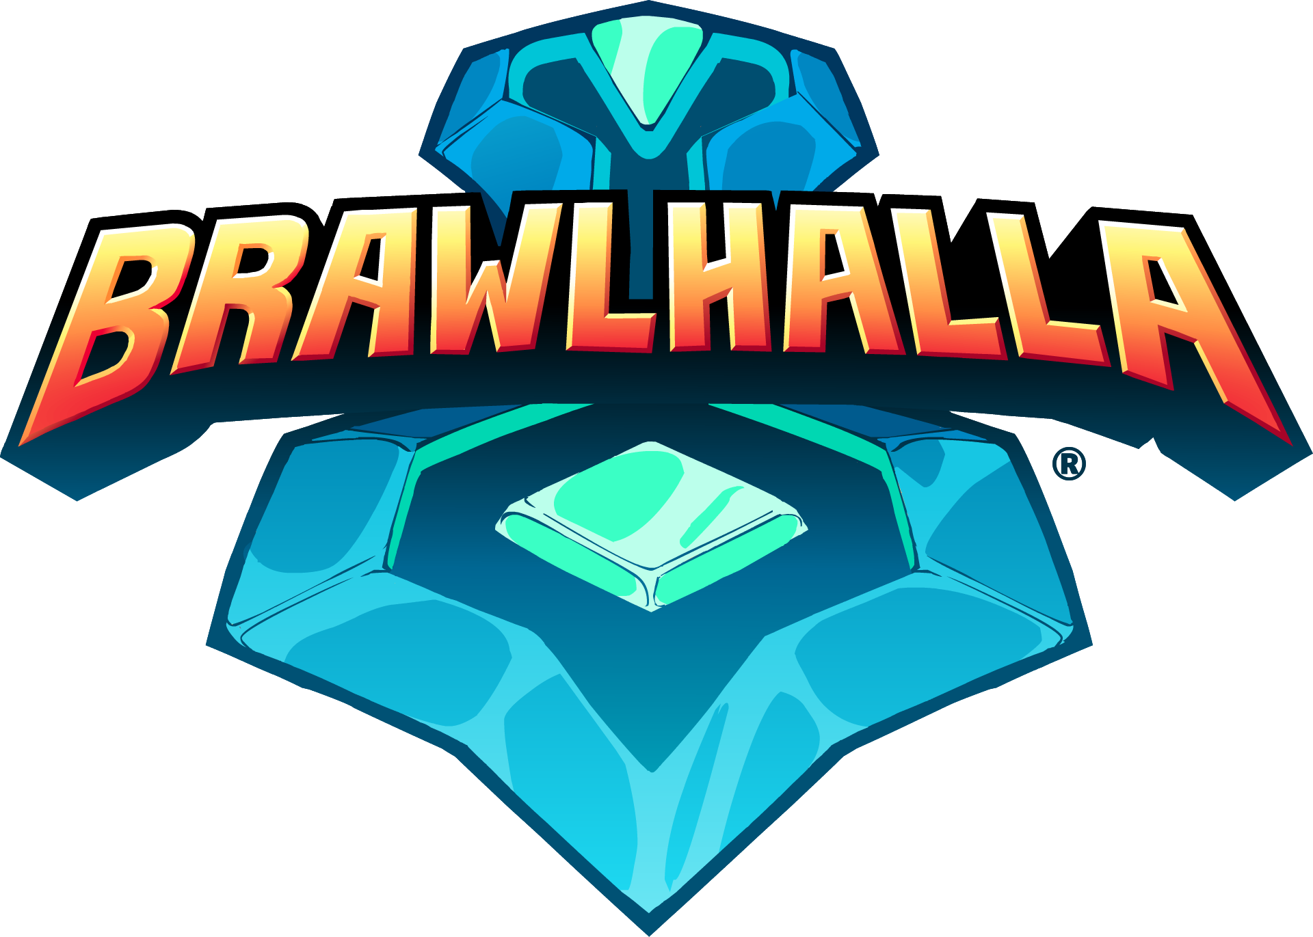
Table of Contents
MSEA Community Guidelines Agreement 2
All Players, Coaches, Spectators, and Organizers must: 2
All Coaches will: 2
Refer to the MSEA Senior Years Rule Guide for general guidelines and rules. 2
Dates 3
Fees 3
Team Registration 3
Season Calendar 4
Season Structure 5
Divisions 5
Why Game Changers? 5
Team setup: 6
Weekly Format: 6
Point system: 6
Game Day Match Creation 7
Legend Locking & Stage Striking 7
Legend Locking (choosing the characters) 7
Stage Striking (eliminating the maps down to the last one to be played on) 7
Substitutions 8
Connectivity Issues 8
In-Game Chat 8
In-game conduct 8
Match Reporting 8
Provincial Finals 9
Contact 9

MSEA Community Guidelines Agreement
- Manitoba School Esports Association strives to provide a safe and welcoming environment for players to compete and an inclusive space for spectators, coaches, and organizers to connect and enjoy the game. Participation in any MSEA tournaments or events requires adherence to the following set of community guidelines for sportsmanship, conduct and ethics.

All Players, Coaches, Spectators, and Organizers must:
- Strive to enhance the safety of all esports participants, spectators, coaches, and organizers by treating everyone with respect, never condoning the use of offensive language, nicknames, or any form of insult towards yourself or others. This includes, but is not limited to racism, sexism, gender identity, sexual orientation, religion, age, or physical ability.
- Uphold the values of sportsmanship, digital citizenship, and integrity by creating a space that is free of language or gestures (physically or in-game) inferring sexual violence or inciting other forms of violence, spamming, or cheating and use of appropriate screen names.
- Respect all participant and spectator information as private and confidential. All age restrictions, Terms of Service, and Privacy Policies for each game, client, and program must be strictly adhered to.

All Coaches will:
- Always be present with their team(s) during competition, whether in person or in voice chat, and to supervise and support students during their competition with MSEA.

Refer to the MSEA Senior Years Rule Guide for general guidelines and rules.

Dates
Registration – January 5-23, 2026
Register here: SYBrawlhalla_GameSheet.xlsx
Coaches Meeting – Tuesday January 13th at 4pm & 8pm on Discord – Will record
Regular Season: Wednesdays February 11th -March 11th
Playoff Tournament: March 18th if needed (depending on number of teams registered)
Provincial In-Person Finals: Saturday March 21st @ Steinbach Regional Secondary School in Steinbach along with the MY Brawlhalla Provincials.

Fees
Schools must be members of MSEA to compete in this Brawlhalla season. MSEA membership includes registration for all of your teams for this Brawlhalla season.

Visit msea.gg or check the #msea-resources channel on discord for membership application and information. If your school is not an MSEA member when you register, we will send you the membership information.

Team Registration
MSEA recommends schools register no more than 3 teams per coach. Trying to coordinate more than 3 teams on game day can be challenging for a single person.

If you would like to register more than 3 teams, please contact the commissioner directly (contact info found at the end of this document). MSEA allows more than 3 teams per school, but we expect all teams to be ready to play at game time. MSEA reserves the right to enforce the rules regarding forfeiture of games if teams are not prepared to play or we feel they are not being monitored by a coach during game time. Please review sections 4 (rescheduling) and 10 (Sportsmanship/Player Behavior) in the General Rules document prior to requesting to register more than 3 teams.

Season Calendar
Jan 2026
S | M | T | W | T | F | S
 |  |  |  | 1 | 2 | 3
4 | 5  Registration begins | 6 | 7 | 8 | 9 | 10
11 | 12 | 13  Coaches mtg 4 & 8 | 14 | 15 | 16 | 17
18 | 19 | 20 | 21 | 22 | 23  Registration Closes | 24
25 | 26 | 27 | 28 | 29 | 30 | 31

Feb 2026
S | M | T | W | T | F | S
1 | 2 | 3 | 4 | 5 | 6 | 7
8 | 9 | 10 | 11  Week 1 | 12 | 13 | 14
15 | 16  Louis Riel Day | 17 | 18  Week 2 | 19 | 20 | 21
22 | 23 | 24 | 25  Week 3 | 26 | 27 | 28

Mar 2026
S | M | T | W | T | F | S
1 | 2 | 3 | 4  Week 4 | 5 | 6 | 7
8 | 9 | 10 | 11  Week 5 | 12 | 13 | 14
15 | 16 | 17 | 18  Playoffs If needed | 19 | 20 | 21  Finals
22 | 23 | 24 | 25 | 26 | 27 | 28
29 | 30 | 31

Season Structure

Divisions
The following division options will be available, when registering choose which division your team best fits. When figuring out where to place a team, you should be placing them in the division their best player would be. One player can often carry in a 2v2 game. If there are not enough teams for a division, that division will be folded into the next higher one.

- “A” – teams are learning about fighting games (i.e. Super Smash Bros, Mortal Kombat, Street Fighter, Tekken, etc.), developing a basic understanding of in-game mechanics, and learning how to play as a team. Likely they will be button mashing.
- “AA” – teams looking for a moderate level of competition. ‘AA’ teams should have a bit of experience in fighting games (i.e. Super Smash Bros, Mortal Kombat, Street Fighter, Tekken, etc.) and are continuing to improve teamwork/communication while developing consistency in their mechanics. They are usually able to recover when they are off the platform (although they can still be working on it), and they are starting to use light (regular attacks) and heavy attacks (power attacks) a little more strategically. These are your teams that are not newbies but aren't doing combos yet.
- “AAA” – skilled teams in a competitive environment. ‘AAA’ teams have a good understanding of fighting games (i.e. Super Smash Bros, Mortal Kombat, Street Fighter, Tekken, etc.), developed mechanics, and good teamwork/communication skills. Teams looking to challenge themselves should enter this division.
- “Game Changers” – An optional choice for female and gender diverse players. All team members must be female or gender diverse.

Why Game Changers?
One of the primary goals of MSEA is to increase participation of female and gender diverse individuals. Experience has taught us that schools tend to have increased participation from these students if they are given their own time and space to play, learn, and grow. Some of these students are happy to participate in a mixed setting with the whole school population but we have found that it can often be intimidating for female and gender diverse students to integrate themselves into a setting dominated primarily by cisgendered teenage boys.

All that to say, this year we have introduced the Game Changers division to allow female and gender diverse students the option to compete exclusively with other members from their community. Participating in Game Changers is a choice. Female and gender diverse students are not required to participate in this division and may register in whichever of the other 3 divisions they fit into based on their skill.

We think you’ll find that when you offer the option to your school population, you’ll have some students come forward to play that you didn’t even realize were interested!

Team setup:
- All teams should provide a set roster of 2-3 players.
- Maximum of 3 teams per coach recommended (see section above)
- All teams are expected to play from school. Exceptions can be made by filling out the appropriate form and forwarding them to the commissioner in a timely manner.

Weekly Format:
- 2 vs 2 games
- Fixed 3 game match – play all 3 games.
- 4 teams in a group - 3 matches per week
- Match opponents will be given on a shared spreadsheet.
- The first week teams will play others randomly. After the first week teams will be put into groups, and we will use a promotion and relegation system each week where the lowest team in a group will move down the ladder and the highest team in a group will move up.
- As per section 4 in the General Rules document (linked above) teams that can’t make a game need to reschedule before noon on the day of the missed game and complete those games before the scheduled matches the next week. Otherwise, they will be forfeited.

Point system:
- 6 points are handed out for each match.
- Each game won is a point.
- Winning the match is two points.
- Losing the match is a point (this is to make it so that playing and losing is more points than defaulting)
- A Bye will count for a single point.
- A forfeit is 0 points, and the other team registers the win and 5 points.

Scenario 1: a sweep:
Team A wins 3 - 0 against Team B
- Team A gets 5 points (3 points for each game won plus 2 for match)
- Team B gets 1 point for playing

Scenario 2: a close fight:
Team A wins 2 - 1 against Team B
- Team A gets 4 points (2 for the game won and 2 for winning match)
- Team B gets 2 points (1 for playing and 1 for winning a game)

Game Day Match Creation
- “Home Team” will create a custom game room 5 minutes before start time.
  - Click on Custom Game Room
  - Next, Create Room and Private Room
  - Then, click on Setting at the top
  - Once there, choose the Lobby tab
  - Select the 2V2 option – the game is ready to go
- “Home Team” coach will communicate the private game room number to “Away Team” coach through the game day spreadsheet.
- All teams log in 5 minutes before official start time.
- “Home Team” captain must ensure that all players are assigned to the correct team.
- All teams hold in lobby until official start time.

Legends
- We will only use the legends available to us as of the first day of competition.

Legend Locking & Stage Striking
There is a specific order to pick legends and the maps to be played that must be followed:

Legend Locking (choosing the characters)
- For the first game of any set, the Away Team must lock in their Legends before the Home team is required to.
- In every other game of the match, the winning team of the previous game must lock in their Legends before the losing team is required to.
- After both teams are locked in, the lobby can move forward and map striking begins.

Stage Striking (eliminating the maps down to the last one to be played on)
- On the first game of any set, the Home Team must strike all but three stages from the map pool. The Away Team may then choose from the remaining three stages by striking two leaving the last one to be the map to be used.
- Every game afterward within the match, the losing team of the previous game must strike all but three stages from the map pool. The winning team of the previous game may then choose from the remaining three stages by striking two.

Substitutions
- Once the roster is set, no substitutions may take place without contacting the commissioner first.
- Teams with a 3-player roster may substitute players in between games (eg. Game 1 – Players 1 & 2 play, and Player 3 spectates, Game 2 Players 1 & 3 play and Player 2 spectates etc.)

Connectivity Issues
In the event of connectivity issues the disadvantaged team will be given 5 minutes of grace to address the issue. After 5 minutes, the match will have to be forfeit.
- Should a player disconnect mid-match: the team will finish out the game with a disadvantage then be given up to 5 minutes to address the issue before the next game starts.
- If the player is able to reconnect mid-game, they will be permitted to play. (Not sure if this is possible)

In-Game Chat
- In-game chat is not permitted during matches, but “gg” is expected at the end of each game regardless of outcome.

In-game conduct
- Any unsportsmanlike behaviour or mid-game chat must be screenshot and reported to the league commissioner.

Match Reporting
- Matches will be reported on the game day spreadsheet
- Home Team coach records the score, and the Away Team coach confirms
- As a backup matches can be reported on discord in the #sy-brawlhalla-chat

Provincial Finals
- Wildcard tournament: TBD
- Finals will be held at Steinbach Regional Secondary School on Saturday March 21st. More details to follow.

Contact
League Commissioner: Aaron Klassen – klassena@blsd.ca
@klassenaa on Discord

